RGB color

Overview：
RGB color LED module can let LED emitting different color lights as RED,BLUE,GREEN signal input. This project will change of color assortment and make the LED flashing like rainbow.

Materials：
Arduino Uno x 1
RGB Led x 1
DuPont wires x 4

Product description :
3-color LED模块由一个贴片全彩LED制成，通过R、G、B三个引脚的PWM电压输入可以调节三种基色（红/蓝/绿）的强度从而实现全彩的混色效果。常被用于KTV、舞台、楼宇等环境，起到灯光装饰作用。

Technical Parameters ：
◆使用贴片全彩LED
◆通过PWM调节三基色可混合得到不同的颜色
◆工作电压：5V
◆驱动模式：共阴驱动

Wiring diagram:

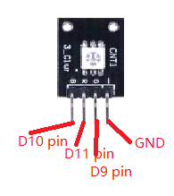
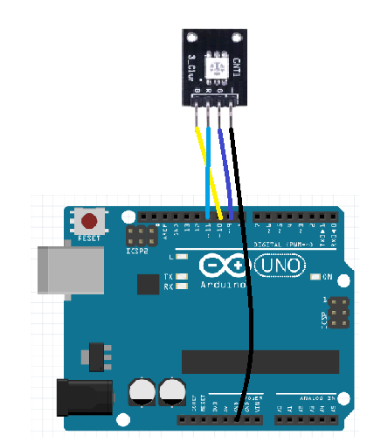

Example code:
/* RGB module project code
*/
int redpin = 11; //select the pin for the red LED
int bluepin =10; // select the pin for the blue LED
int greenpin =9;// select the pin for the green LED

int val;

void setup() {
pinMode(redpin, OUTPUT);
pinMode(bluepin, OUTPUT);
pinMode(greenpin, OUTPUT);
Serial.begin(9600);
}

void loop()
{
for(val=255; val>0; val--)
{
analogWrite(11, val);
analogWrite(10, 255-val);
analogWrite(9, 128-val);
delay(2);
}
for(val=0; val<255; val++)
{
analogWrite(11, val);
analogWrite(10, 255-val);
analogWrite(9, 128-val);
delay(2);
}
Serial.println(val, DEC);
}

Experimental phenomena：

3色LED灯循环发出红色、绿色、蓝色、黄色、洋红色、青色的灯光。

